**COAL LAB 06 - 13 Mar 2025**

**Student Name:** Ibrahim Johar Farooqi

**Student ID:** 23K-0074

***Task 1:***

include irvine32.inc

.code

main PROC

mov eax, 0

mov ebx, 1

mov ecx, 10

L1:

call WriteDec

call Crlf

add eax, ebx

xchg eax, ebx

loop L1

exit

main ENDP

END main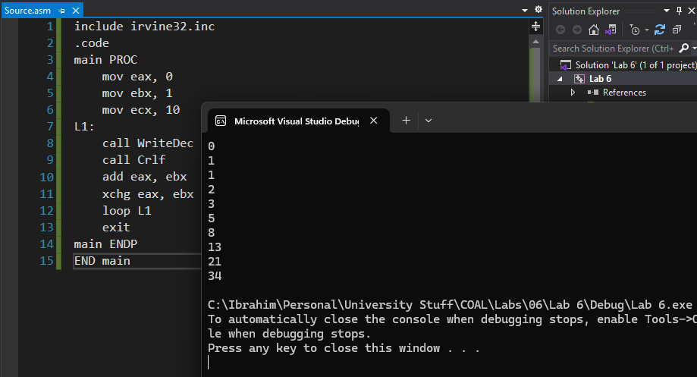

***Task 2 - Part 1:***

include irvine32.inc

.data

num DWORD 1

count DWORD 0

.code

main PROC

mov ecx,4

L1:

mov count,ecx

mov ecx,4

sub ecx,count

add ecx,1

L2:

mov eax,num

call WriteDec

mov al,' '

call WriteChar

Loop L2

call crlf

mov ecx,count

Loop L1

exit

main ENDP

END main

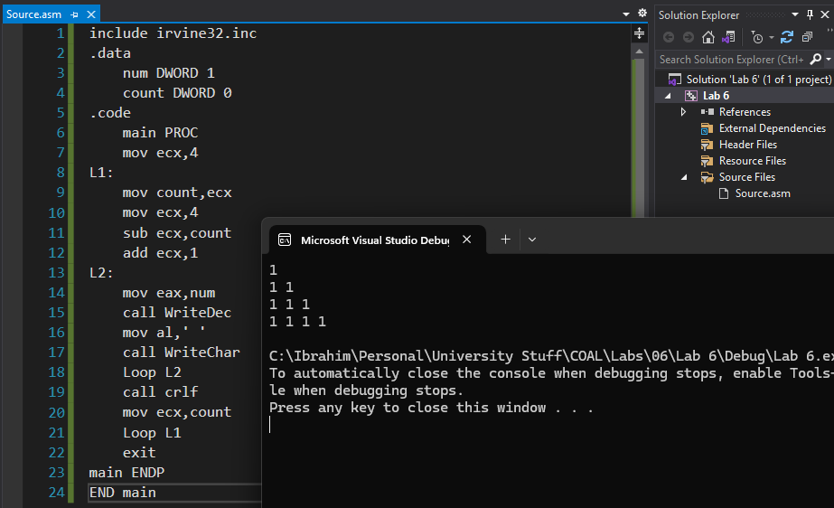

***Task 2 - Part 2:***

include irvine32.inc

.data

num DWORD 1

count DWORD 0

.code

main PROC

mov ecx,4

L1:

mov count,ecx

mov ecx,count

L2:

mov eax,num

call WriteDec

mov al,' '

call WriteChar

Loop L2

call crlf

mov ecx,count

Loop L1

exit

main ENDP

END main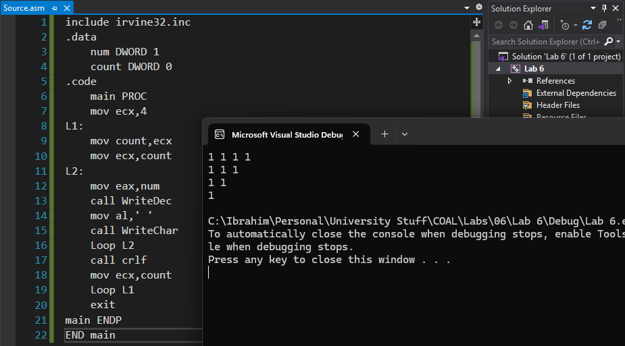

***Task 2 - Part 3:***

include irvine32.inc

.data

num DWORD ?

count DWORD 0

.code

main PROC

mov ecx,4

L1:

mov count,ecx

mov ecx,count

mov num,4

L2:

mov eax,num

call WriteDec

mov al,' '

dec num

call WriteChar

Loop L2

call crlf

mov ecx,count

Loop L1

exit

main ENDP

END main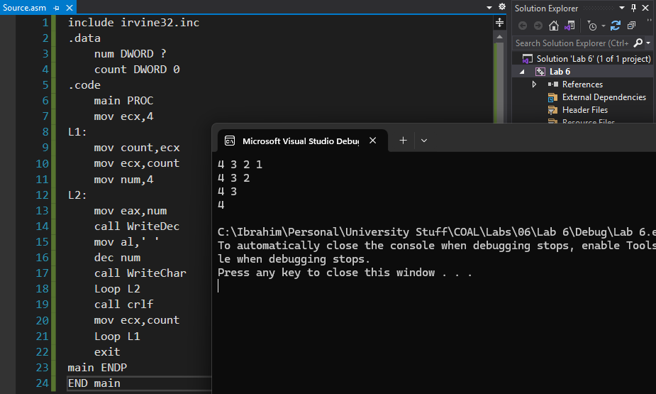

***Task 2 - Part 4:***

include irvine32.inc

.data

num DWORD ?

count DWORD 0

.code

main PROC

mov ecx,4

L1:

mov count,ecx

mov ecx,count

mov num,1

L2:

mov eax,num

call WriteDec

mov al,' '

inc num

call WriteChar

Loop L2

call crlf

mov ecx,count

Loop L1

exit

main ENDP

END main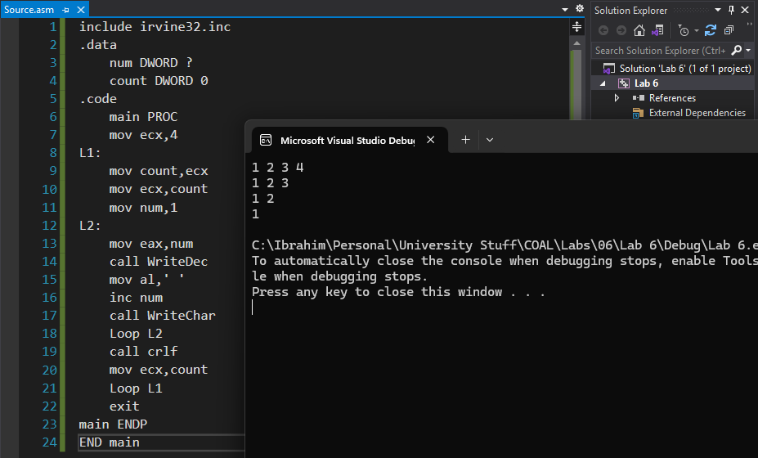

***Task 3:***

include irvine32.inc

.data

employees DWORD 5

Ids DWORD 5 DUP(?)

names BYTE 5 DUP(20 Dup(?))

birthyear DWORD 5 DUP(?)

annualSalary DWORD 5 DUP(?)

msg1 db 'enter employee id ',0

msg2 db 'enter employee name ',0

msg3 db 'enter employee date of birth ',0

msg4 db 'enter employee annual salary ',0

msg5 db 'annual salary for all employees ',0

.code

main PROC

mov ecx,employees

mov esi,0

mov edi,0

L1:

mov edx,offset msg1

call WriteString

call ReadDec

mov Ids[esi],eax

mov edx,offset msg2

call WriteString

mov ebx,ecx

mov edx,offset names

add edx,edi

mov ecx,20

call ReadString

mov ecx,ebx

add edi, 20

mov edx,offset msg3

Call WriteString

call ReadDec

mov birthyear[esi],eax

mov edx,offset msg4

Call WriteString

call ReadDec

mov annualSalary[esi],eax

add esi,4

call crlf

Loop L1

mov ecx,employees

mov esi,offset annualSalary

mov eax,0

L2:

add eax,[esi]

add esi,TYPE annualSalary

Loop L2

mov edx, OFFSET msg5

Call WriteString

call WriteInt

exit

main ENDP

END main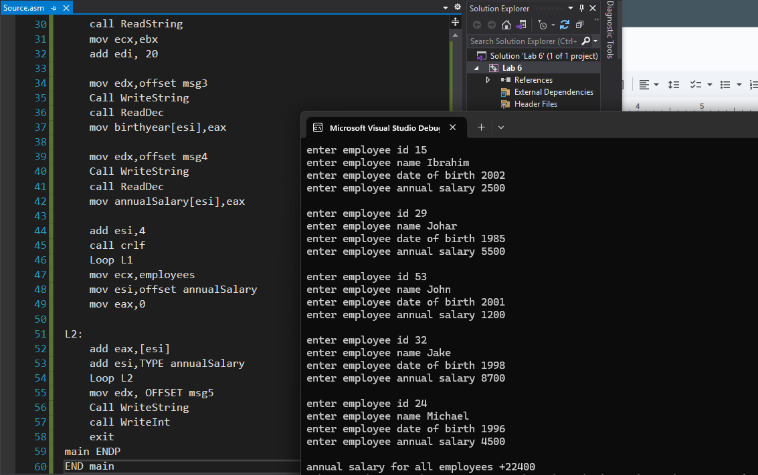

***Task 4:***

include irvine32.inc

.data

source BYTE "Ibrahim Johar - Task 4",0

target BYTE SIZEOF source DUP(?)

.code

main PROC

mov esi,0

L1:

mov al,source[esi]

mov target[esi],al

inc esi

cmp al,0

jne L1

mov edx,offset target

call WriteString

exit

main ENDP

END main

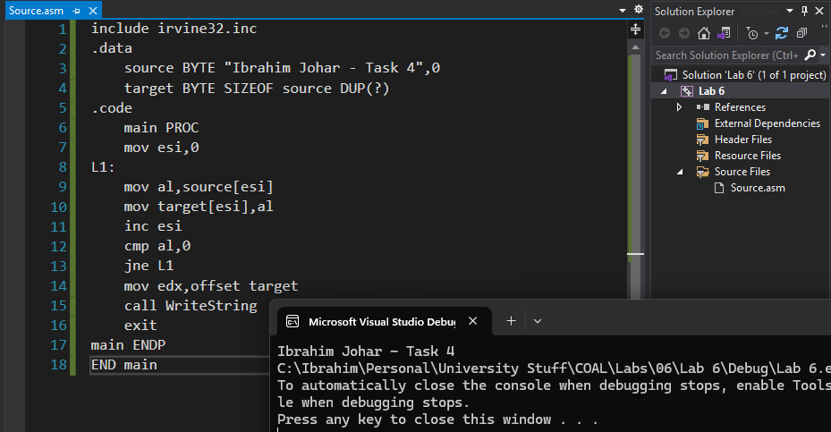

***Task 5:***

include irvine32.inc

.data

arr BYTE 1,2,3,4,5

.code

main PROC

mov ecx,(LENGTHOF arr)/2

mov esi,0

mov edi,4

L1:

mov al,arr[esi]

mov bl,arr[edi]

mov arr[esi],bl

mov arr[edi],al

inc esi

dec edi

Loop L1

mov ecx,LENGTHOF arr

mov eax,0

mov esi,offset arr

L2:

mov al,[esi]

call WriteInt

inc esi

Loop L2

exit

main ENDP

END main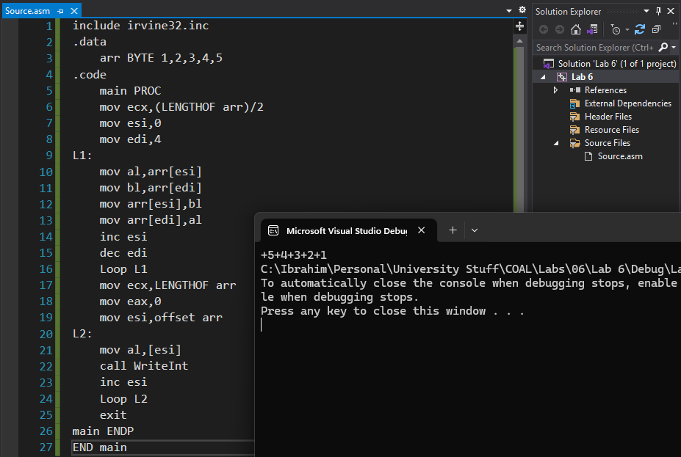

***Task 6:***

include irvine32.inc

.data

arr DWORD 8,5,1,2,6

count DWORD ?

.code

main PROC

mov ecx,LENGTHOF arr

L1:

mov count,ecx

mov ecx,LENGTHOF arr

dec ecx

mov esi,0

L2:

mov eax,arr[esi]

mov edi,esi

add edi,TYPE arr

mov ebx,arr[edi]

CMP eax,ebx

JG SWAPPING

L3:

add esi,TYPE arr

Loop L2

mov ecx,count

Loop L1

JMP DISPLAY

SWAPPING:

mov arr[edi],eax

mov arr[esi],ebx

JMP L3

DISPLAY:

mov ecx,LENGTHOF arr

mov esi,0

L4:

mov eax,arr[esi]

call WriteInt

mov al,' '

call WriteChar

add esi,TYPE arr

Loop L4

exit

main ENDP

END main

